**Disaster Recovery with IBM Cloud Virtual Servers**

**\*\*\*\*\*\***

**Problem Definition:**

The primary challenge of this project is to establish a robust disaster recovery plan using IBM Cloud Virtual Servers. The main objective is to safeguard business operations by developing a plan that ensures continuity for an on-premises virtual machine in unforeseen events. This plan will encompass setting up backup strategies, configuring replication, testing the recovery process, and guaranteeing minimal downtime.

The project can be broken down into the following key components and Design Thinking:

**1. Disaster Recovery Strategy:**

Recovery Time Objectives (RTO): The maximum allowable downtime for systems and operations.

Recovery Point Objectives (RPO): The maximum allowable data loss in case of a disaster.

**2. Backup Configuration:**

Configure regular backups of the on-premises virtual machine to capture critical data and configurations.

**3. Replication Setup:**

Implement replication of data and virtual machine images from the on-premises environment to IBM Cloud Virtual Servers.

**4. Recovery Testing:**

Design and conduct recovery tests to validate the recovery process.

Simulate various disaster scenarios to ensure the plan's effectiveness.

Identify and address any weaknesses or bottlenecks in the recovery process.

Document the results and improvements made during testing.

**5. Business Continuity:**

Collaborate with key stakeholders to ensure that business operations can continue seamlessly during and after a disaster.

Consider factors such as communication plans, resource allocation, and alternative work arrangements.

**Objectives of a Disaster Recovery Strategy:**

* Minimize Downtime: Ensure that critical systems and services can be restored quickly to minimize business disruption and financial losses.
* Protect Data: Safeguard data integrity and availability by implementing backup and recovery mechanisms that meet RPO requirements.
* Ensure Compliance: Comply with regulatory and legal requirements for data retention, security, and disaster recovery.
* Resource Allocation: Allocate resources (people, technology, budget) effectively to support the DR strategy.
* Testing and Validation: Regularly test and validate the DR plan to ensure its effectiveness and make necessary improvements.
* Communication: Establish clear communication and escalation procedures to keep stakeholders informed during a disaster.
* Cost Control: Balance the cost of implementing DR measures with the potential losses that could occur during downtime.

**Risk Assessment and Impact Analysis:**

* Potential risks and threats:

1. Natural Disasters:

Earthquakes: Especially in regions prone to seismic activity.

Hurricanes/Cyclones/Typhoons: Coastal and island areas are vulnerable.

Floods: For businesses located near bodies of water or in flood-prone regions.

Wildfires: Particularly relevant in arid and forested regions.

Tornadoes: More common in certain parts of the world.

Blizzards and Winter Storms: In areas with cold climates.

2. Man-Made Disasters:

Cyberattacks: Including data breaches, ransomware attacks, and distributed denial of service (DDoS) attacks.

Physical Security Threats: Such as theft, vandalism, or unauthorized access to facilities.

Terrorism: Depending on the geopolitical situation.

Industrial Accidents: For businesses dealing with hazardous materials or industrial processes.

Supply Chain Disruptions: Due to factors like transportation issues, trade disputes, or supplier failures.

3. Health and Pandemic Risks:

Pandemics and Infectious Diseases: As demonstrated by the COVID-19 pandemic.

Health and Safety Concerns: Workplace accidents, disease outbreaks among employees, or occupational health hazards.

4. Environmental Risks:

Climate Change: Impacting businesses through extreme weather events, resource scarcity, and regulatory changes.

Environmental Regulations: Compliance with evolving environmental laws and regulations.

5. Technology and Infrastructure Risks:

IT Failures: Such as server crashes, network outages, or software bugs.

Power Outages: Including grid failures or localized power disruptions.

Communication Failures: Interruptions in internet connectivity or telecommunications services.

6. Financial Risks:

Economic Downturns: Economic recessions or financial crises that affect consumer spending and business investments.

Market Volatility: Fluctuations in commodity prices, exchange rates, or stock markets.

7. Legal and Regulatory Risks:

Lawsuits and Legal Actions: Including litigation, regulatory fines, or intellectual property disputes.

Compliance Failures: Violations of industry-specific or government regulations.

8. Human Resource Risks:

Workforce Shortages: Due to factors like talent shortages, labor strikes, or mass resignations.

Leadership and Key Personnel Changes: Sudden departures of key executives or personnel.

9. Social and Political Risks:

Political Instability: In regions with political unrest, protests, or regime changes.

Social Media and Reputation Risks: Negative public sentiment amplified through social media platforms.

10. Infrastructure Risks:

Facility Failures: Building-related issues like structural problems, fires, or equipment failures.

* Impact Analysis:

Business Impact Analysis (BIA):

Perform a BIA to determine the financial, operational, and reputational consequences of downtime or data loss. This analysis will help prioritize which systems and data require the highest level of protection and recovery.

* Recovery Time Objective (RTO):

RTO is the maximum acceptable downtime for a system or service following a disaster or incident. It represents the time frame within which a system or application must be restored to normal operation to avoid significant business impact.

RTO is typically expressed in hours, minutes, or even seconds, depending on the criticality of the system or application.

The choice of RTO depends on factors such as the importance of the system, its role in supporting critical business functions, and the cost associated with achieving faster recovery times.

High-priority systems may have very low RTOs, while less critical systems may have longer RTOs.

* Recovery Point Objective (RPO):

RPO is the maximum allowable data loss that an organization can tolerate in the event of a disaster or incident. It defines the point in time to which data must be recovered to resume normal operations.

RPO is typically measured in terms of time, such as hours or minutes. For example, an RPO of 1 hour means that data must be recoverable up to 1 hour before the disaster occurred.

The choice of RPO depends on the nature of the data and its criticality to business operations. Critical data may have a very low RPO, while less critical data may have a longer RPO.

**Budget and Business continuity plan for Disaster Recovery with Cloud Virtual Servers:**

1. Budget Considerations:

* Initial Setup Costs:

Hardware and software procurement or subscription costs for IBM Cloud services and replication tools.

Costs associated with network connectivity, such as VPN or dedicated connections.

Costs for setting up storage in IBM Cloud (e.g., IBM Cloud Object Storage or Block Storage).

* Operational Costs:

Ongoing subscription fees for IBM Cloud services, including Virtual Servers and storage.

Licensing fees for backup and replication software.

Data transfer and storage costs based on usage.

Costs for monitoring and alerting tools to ensure the health of the disaster recovery setup.

* Human Resources:

Staff salaries and benefits for IT personnel responsible for managing and maintaining the disaster recovery solution.

Training costs to ensure that IT staff is well-equipped to handle disaster recovery tasks.

* Testing and Validation:

Costs associated with conducting regular disaster recovery tests, including the allocation of resources, time, and any expenses incurred during testing.

* Security Measures:

Budget for implementing and maintaining security measures, such as encryption and access controls, to protect data in transit and at rest.

* Documentation and Compliance:

Costs for documenting disaster recovery plans, procedures, and compliance-related activities.

Fees associated with compliance audits and certifications, if applicable.

* Contingency and Emergency Response:

Funds set aside for unforeseen expenses related to disaster recovery, such as equipment replacement or emergency response actions.

* Consulting Services:

Budget for hiring external consultants or experts for advice and assistance in disaster recovery planning and implementation.

2. Business Continuity Plan Integration:

* Alignment with Business Objectives:

Ensure that the budget aligns with the organization's overall business objectives and strategies, including business continuity goals.

* Risk Assessment and Prioritization:

Use the results of risk assessments and business impact analyses to prioritize budget allocation for critical systems and processes.

* Regular Review and Updates:

Incorporate a process for regularly reviewing and updating the budget to reflect changes in technology, infrastructure, and business needs.

* Contingency Planning:

Develop a contingency budget for situations where unexpected costs arise during disaster recovery operations.

* Testing and Validation:

Allocate budget for conducting regular disaster recovery tests and exercises, as these are essential for validating the effectiveness of your plan.

* Employee Training:

Include budget for training employees on their roles and responsibilities in the event of a disaster.

* Documentation and Compliance:

Allocate resources for maintaining documentation and ensuring compliance with industry-specific regulations and standards.

3. Budget Approval and Monitoring:

* Approval Process:

Define the process for budget approval, including the involvement of key stakeholders and decision-makers.

* Financial Oversight:

Appoint a responsible individual or team for financial oversight and monitoring to ensure that the budget is effectively managed and adhered to.

* Cost Tracking and Reporting:

Implement a cost-tracking system to monitor expenses related to disaster recovery. Regularly report on budget performance.

* Budget Adjustments:

Establish procedures for making budget adjustments in response to changing circumstances or unexpected costs.

4. Communication:

Communicate the budget plan and its importance to relevant stakeholders, including senior management, IT teams, and business units.

Flow chart:

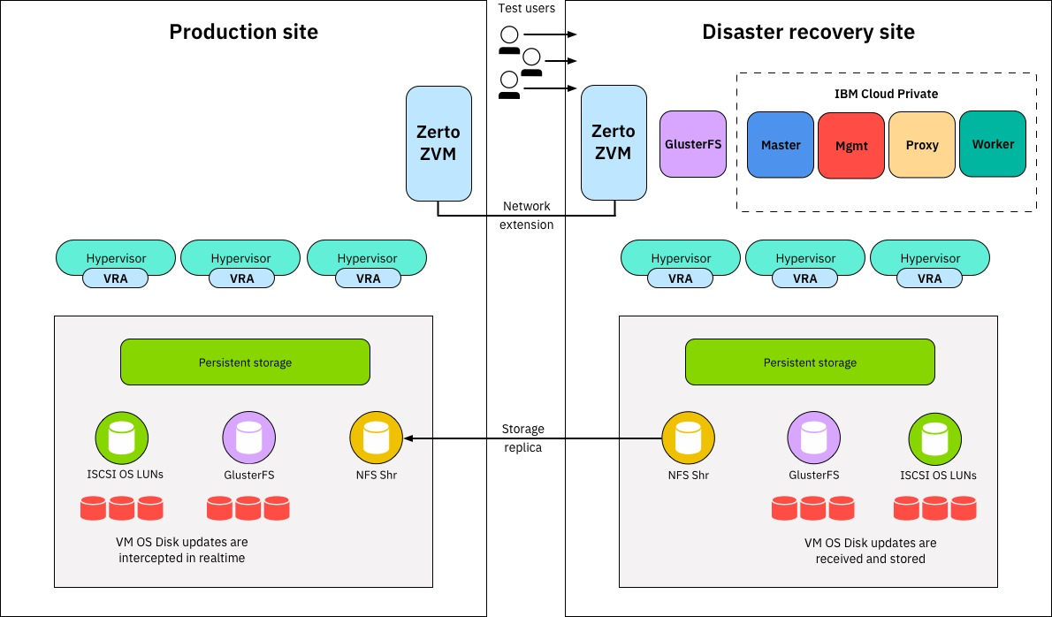

**Conclusion:**

Implementing disaster recovery with IBM Cloud Virtual Servers is a crucial step in ensuring the resilience and continuity of your business operations. By leveraging the capabilities of IBM Cloud, you can address a wide range of potential threats and disruptions, from natural disasters to cyber attacks.

**\*\*\*\*\*\***